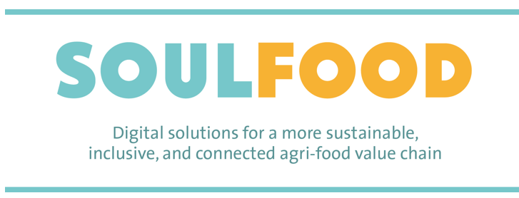

Call announcement for the selection
of third parties
(Open Call for agri-food producers)

Table of Contents

- The SOULFOOD PROJECT
  - The SOULFOOD Project in brief
  - SOULFOOD Objectives
  - Who we are

- THE CALL FOR AGRIFOOD PRODUCERS. TERMS & CONDITIONS.
  - Why should agrifood producers participate?
  - Who can apply?
  - What are participants commitment?
  - What is the budget of the call?
  - What is the calendar of the call?
  - What do we offer?
  - What happens if the call procedure remains unsuccessful?
  - How and when the participants will be paid?
  - How to apply?
  - How is the call financed?

- EVALUATION PROCESS
  - Evaluation committee
  - Minimal eligibility conditions
  - Eligibility criteria

- ADDITIONAL INFORMATION: DISSEMINATION ACTIVITIES AND FURTHER INFORMATION / PUBLICATION OF THE CALL

- TESTING PROCESS OF THE SELECTED PARTICIPANTS

- CONFIDENTIALITY AND COMMUNICATION

ANNEXES

ANNEX I: Producer’s call timetable

ANNEX II: Application Form and Declaration of Honour

ANNEX III: Evaluation Form

The SOULFOOD Project

  - The SOULFOOD Project in brief

The SOULFOOD project “Digital solutions for a more sustainable, inclusive, and connected agrifood value chain’, tests innovative digital solutions to help reduce food loss, contributing to a more sustainable agri-food sector, and improving the efficiency of food distribution/donation initiatives for vulnerable groups implemented by NGOs and local governments.

This project has the participation of the Provincial Council of Tarragona (project Coordinator), the City Council of Reus, REDESSA with the Hub Foodtech & Nutrition, the Southern Catalonia TIC Cluster and the Espigoladors Foundation. It also has four European partners, leaders in the agri-food and social innovation sectors: the Lithuanian Innovation Center (Lithuania), the Digital Innovation Hub Agri-Food (Lithuania), the City Council of Roman (Romania) and the NGO Boroume – Saving food saving lives (Greece).

The project has a global budget of 801,739.88 euros, 90% of which is financed by the European Social Fund Plus

  - SOULFOOD objectives
- Reduce food loss, contributing to a more sustainable agri-food sector, and improve the efficiency of food distribution/donation initiatives for vulnerable groups implemented by NGOs and local governments.
- Increase the digitalization of the main agents of the value chain (producers and social initiatives).
- Improve the networks between local agri-food producers and the social initiatives of food distribution in the participating communities, to promote new collaborations for the reuse of lost food for social purposes.
- Raise awareness of the problem of food loss among the main actors in the value chain and the public.

  - Who we are

The project consortium brings together nine partners from four different European countries, representing the different expertise needed to achieve its objectives. The partners are:



The Diputació de Tarragona is a supra-municipal organization that works to improve of the quality of life of the people, the municipalities and the counties of Camp de Tarragona, the Terres de l'Ebre and the Baix Penedès. It provides services, provides technical and legal coverage and delivers state funds for infrastructure, culture or education to the municipalities of the demarcation. It coordinates the SOULFOOD project and leads its communication activities.
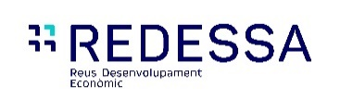

It is a municipal company of Reus City Council that works alongside companies, entrepreneurs, startups and spinoffs, to help them grow their projects. He coordinates the recently created Foodtech & Nutrition Hub, which brings together the ICT sector with the agri-food sector.

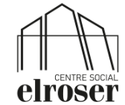
The El Roser Social Center is an integrative, inclusive and innovative municipal facility of the Reus City Council. It is the culmination of a landmark project that structures a care and empowerment plan for people in vulnerable situations, designed and developed by the Social Welfare Department of Reus City Council, which currently manages it. For all this, it is the most important challenge in the social field that has been made in Reus in the last decades.

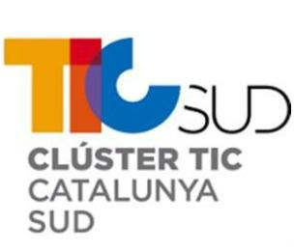
The Cluster TIC Catalunya Sud is an association promoted by the public sector and led by the private sector, which has the support of the Universitat Rovira i Virgili. Our main objective is to promote and contribute to the competitiveness in the value chain of the Information and Communication Technologies sector in the Camp de Tarragona and Terres del Ebre. At present, the Cluster TIC Catalunya Sud is made up of more than eighty companies that generate more than 1500 direct jobs.
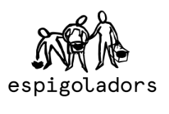
The Espigoladors foundation is a non-profit organization. Since 2014 they have been working to prevent food loss and food waste. With a transformative, inclusive, participatory and sustainable approach, they seek to guarantee the right to healthy and sustainable food for everyone. Gleaning is their activity, which helps them combat food loss and is where their name comes from.
Through picking, the volunteers of Espigoladors recover surplus fruits and vegetables directly from the fields to distribute them among social entities and food banks that work to guarantee access to sustainable food for people in vulnerable situations.
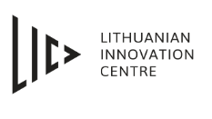
Since 1996, this innovation center, specialized in the development and implementation of digital technologies in the industrial, agri-food and energy sectors, has been developing its activity. It offers innovation support services and integrates Lithuanian innovation support entities into international value chains.
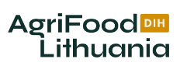
AgriFood Lithuania is a digital innovation hub and cluster that brings together the main research agents, companies and the public for the common research of digital transformations in agriculture, food and associated sectors. It links stakeholders with international and cross-sectoral initiatives to provide comprehensive support in the development and deployment of agri-food innovations. The innovative agri-food ecosystem it has created involves all actors in the food value chain, from primary producers to consumers. The organization promotes more than 300 events annually and collaborates in at least 50 initiatives. It offers services to public and private actors, such as collaborations to build stakeholder ecosystems, knowledge transfer, use case validations or innovation, and project co-creation.
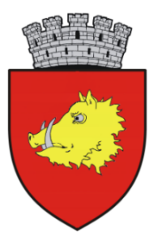

UATR. MUNICIPALITY OF ROMAN. It is the second city in Neamț County and among the largest municipalities in Romania. The Municipality of Roman has strong experience in EU projects: -12 projects submitted for European funds, +6 already won. It has contacts with a private food bank in Romania and with County’s local producers.
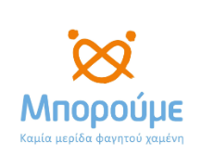

Boroume is a Greek non-profit organization founded with the aim of reducing food waste and increasing donations to the country, through food savings programs that cover every stage of the value chain and various educational and increase programs the awareness. Boroume has also created and coordinated Greece's national voluntary agreement on food waste reduction (Alliance for the Reduction of Food Waste), as well as one of the first food saving certifications called "No Food Waste". Since their beginnings in 2012, they have saved and offered 70 million portions of food to 650 charity initiatives throughout Greece. It has been recognized with the European Citizen Award 2017 by the European Parliament and is an active member of the European platform on food loss and food waste since its creation in 2016.

The Call for Agri-food producers; terms and conditions

The transition to more sustainable production and consumption patterns in the food sector is one of the social challenges that needs to be addressed to ensure that Europe achieves the objective of reducing food waste by 50% by 2030.
In 2020, 8’6% of the EU population and more than one in five people at risk of poverty (21’7%) were unable to afford a meal with meat, fish or a vegetarian equivalent every second day.
On the other hand, food-loss is still a non-solved challenge in the agri-food sector in Europe.

SOULFOOD is launching the first Open Call in June 2024 to allow European agri-food producers to test a digital tool developed in the SOULFOOD project that helps to manage their food-losses and its re-use by social initiatives of food-distribution. This digital tool will improve the connection among local agri-food producers and the social initiatives of food distribution in the participating communities, promoting new collaborations that allow the reuse of food-loses for social purposes, while contributing to improve food-loss management in the agri-food producers.

The purpose of this Callis to structure and set the criteria and the procedure for the granting of subsidies granted by AgriFood Lithuania to test a digital tool. The granting of subsidies governed by this call will be carried out in accordance with the principles of publicity, transparency, competition, objectivity, equality and non-discrimination.

In the following sections you will find the detail of the terms and conditions that regulate the call.

- Why should agri-food producers participate?

Participants will have the opportunity to test a digital tool that will allow them:

1. To manage their food losses, helping to reduce them and the related CO2 emissions, achieving a more sustainable and efficient productions patterns in their activity thanks to the digital tool, helping reduce food-losses, the water footprint and the related CO2 emissions.

2. Increase in digitalization: The tool promotes the digitalization of producers, providing them with a technological platform to efficiently manage their operations, from inventory to distribution.
3. Improve their networks and collaborations: It facilitates the creation of networks between local producers and social entities, promoting collaborations that can lead to new business opportunities and the reuse of lost food for social purposes.
4. Increase in awareness and training: Through the platform, producers can access valuable information on sustainable practices and participate in training activities, thus contributing to greater awareness about food loss.
5. Intuitive interface and customized functionalities: The application is designed to be intuitive and easy to use, with the ability to create multiple profiles and adjust functionalities according to the specific needs of producers and social entities.
6. Analysis and reporting: The tool will provide reports and analytics that will help producers make data-driven decisions, thus improving the management of their resources and operations.

The platform allows producers to propose donations which must be accepted by recipients and carriers. It tracks donations through various statuses, such as pending acceptance, approved, in transit, and delivered, with each status change generating email notifications. The system supports a comprehensive back-end for donation settings, allowing producers to specify details like product name, weight, volume, and perishability.

This combination of advantages not only optimizes the operations of local producers but also enhances their social responsibility and community contribution.

Who can apply? What are the eligibility criteria?
To be eligible for this call, candidates should meet these conditions:
- Be an enterprise or a self-employed worker with an agri-food economic activity up to 100 workers with the corresponding administrative permits inherent in the activity.
- Be an agrifood producer from one of the following categories, corresponding to Nace codes A.1.1, A.1.2:
A1 - Crop and animal production, hunting and related service activities:
  - A.1.1- Growing of non-perennial crops
  - A.1.2 Growing of perennial crops
- Be registered in the Republic of Lithuania.
- Present all the required documentation in Annex II:
a) In the case of a natural person, be duly registered with the Public Treasury and the Social Security as a self-employed person.
b) In the case of a legal person, this must be private and must be duly constituted and registered in the corresponding public register.

What are participants’ commitments?
Throughout the project’s lifespan, the selected participants shall comply with the following requirements:
- Each applicant will test the digital tool during the entire testing period.
- The applicants will not transfer or assign directly or indirectly any portion of the support to other ends not included in the initial application
- The applicants will follow the rules and requirements of the call and in accordance with the contract
- The applicants will designate a person to lead the communication between the applicant and the SOULFOOD consortium throughout the duration of the project.
- The applicants will supply any information requested by the SOULFOOD consortium partners for the purpose of ensuring that these requirements are complied with any written request or direction received from the European Commission concerning the proper management of the testing tool
- The applicants will not be entitled to require further supporting for the mere reason that they disagree with the results of the support by the SOULFOOD consortium partners

What is the budget of the call?
The budget of the action plan submitted for funding is 9.000 €. This amount will be divided by 6 producers receiving each of them the amount of 1.500€ (tax exempt).

What is the calendar of the call?

See at the Annex I the calendar of the call and the first phase.
The timeframe planned for the implementation of the digital too will be from June 2024 to May 2025, divided in two different phases:
- Phase 1- Producer’s testing period To be completed at the end of 3rd Quarter of 2024.
- Phase 2- Producer’s and social initiatives testing period To be completed by the 2nd Quarter of 2025.

What do we offer?

Economic compensation: 9 producers’ beneficiaries in total will be selected: 3 in Spain and 6 in Lithuania. Each beneficiary in Spain will receive financial support of maximum 3.000€ and 1.500€ in Lithuania to comply the requirements explained in the section of this document named “What are participants commitment?”.
The possibility to test an innovative digital tool to manage food-loss and its redistribution to social initiatives.
Interact in a European project and with peer European producers
Learn about sustainable and innovative good practices related to food loss prevention and social initiatives of food-distribution
Visibility of your socially and environmentally responsible action.

What happens if the call remains unsuccessful?
In case the call does not receive any candidates, it will be reopened in the shortest period possible, with revised conditions if necessary.

How and when will the participants be paid?
The financial support will be transferred to the selected participants in two payments. The first one in November 2024 and the second one in March, or in any case at the end of the testing.

How to apply?

Applicants are required to complete the application form. The application form can be found in the Open Call Annex II, as well as on the project partner’s, AgriFood Lithuania DIH, website https://www.agrifood.lt/soulfood-kviecia-ukininkus-testuoti-iranki-skirta-agromaisto-tvarumui/.
Besides, applicants will have to complete and present the documentation required in the Annex II. See the timetable in the Annex I.
- Call opening date: 11th June 2024, 09:00 CET
- Submission deadline: 26th June 2024, 23:59 CET.
During this period, questions on the application process can be addressed at: edita@agrifood.lt. All submitted proposals received after the submission deadline will not be considered.
There will be a 4-days period where The Evaluation Committee will study the submitted Applications from 27th June to 3rd July.
Applicants will be informed about the outcome of their application by July 4th 2024 by the means of electronic mail.
The producers that have not been selected will have one week to present their disagreements to be evaluated, by the second week of July 2024.
The first two weeks of July 24, the producer’s contract will be created, delivered, and signed. The kick-off-meeting to present the demo of the digital tool will be held by mid-July 2024.
The producers will start testing the digital tool by mid-July 2024 until the end of September. The second phase of testing (producers and social entities) will last from November 2024 until the end of May 2025.
Please note that all information provided will be treated confidentially and stored only for the purpose of this call.
English, Spanish and the local Language are the official language for the SOULFOOD Open Call. Submissions done in any other language will not be evaluated.

How is this call financed?
This call uses funds obtained within the scope of SOULFOOD project, co-financed by the European Union in the framework of European Social Fund Plus program, call ESF-2022-SOC-INNOV (Project ID 101102485-SOULFOOD-ESF-2022-SOC-INNOV).

Evaluation process
3.1 Evaluation Committee

The evaluation of each submitted application will be carried out by an Evaluation Committee consisting of Soulfood consortium partner. AgriFood Lithuania DIH is on charge of distributing the funds to third parties and represents the technological enterprises from the territory. AgriFood Lithuania DIH will ensure that the most suitable candidates are selected.
3.2 Minimal eligibility conditions

An application will be eligible only if all the following eligibility criteria are met:
- it must be presented before the submission deadline date (see ANNEX I) applying the requested submission procedure
- all the required fields in the application form (see ANNEX II) must be completed
- all the documents required in the application form (see ANNEX II) must be presented
- the candidate is an enterprise, up to 100 workers, or a self-employed worker
- the candidate is an agrifood producer from one of the following categories, corresponding to Nace codes A.1.1, A.1.2
- the candidate is registered in Lithuania

The candidates’ official representative declares that the agrifood producer’s actions follow EU regulations by signing the ANNEX II (Application form and intentions declaration)

The candidates’ official representative declares no Incompatibility with other EU funding for the same actions. This will be declared when completing the application form, where applicants are asked to confirm that no conflict of interest could arise in connection with this open call. This will ensure to prevent any situation where the impartial and objective selection of the proposal is compromised for reasons involving economic interest, political of national affinity, family or emotional ties or any other shared interest (“conflict of interest”). Applicants who cannot confirm that there is no conflict of interest, will not be considered for the selection. – ANNEX II

3.3 Evaluation criteria
The evaluation process will be managed by three internal evaluators. The evaluation and selection will be based on four main criterion, given that the eligibility conditions are met. Each criterion can receive from 1 to 5 points, 1 being the lowest score and 5 being the highest. The best 3 scores will be the selected producers to test the digital tool.
The maximum number of points that an applicant may receive is 20.

The Evaluation Form follows the example of the Guidelines for awarding Financial Support to Third Parties of CALL ESF-2022-SOC-INNOV and is available in the ANNEX III. In this annex there is a detailed explanation of the 4 main criteria.

The scoring will consider the average score of the members of the Evaluation Committee. The three members of the selection committee need to participate in the evaluation to assign a final score.
The Evaluation Committee will evaluate each application in a transparent and fair way, respecting the confidentiality of any information identified as confidential at the time it is provided. Evaluations will be performed applying the highest ethical and moral standards.
The applicant’s contact person (provided in the form) may be contacted during the evaluation to provide further clarification on all aspects of the application.
The applicants will be informed about the decision made by the Evaluation Committee by the end of June 2024 via email. The notification can be:
- Not selected: your application has not been selected for the programme, based on ‘on-off’ criterion.

- Not selected (in reserve list): your application has not been selected for the programme but has been put in reserve list, in case one of the selected companies does not finally participate.

- Selected: your application has been selected for the programme. The SOULFOOD consortium partners will prepare the contract with regard to the specific terms and conditions of the service.
The final decision will also be published on the AgriFood Lithuania DIH website.
Within 3 working days of the reception of the communication, applicants may submit a request for redress if they believe that there has been a shortcoming in the way their proposal has been evaluated that may affect the final decision on whether they are selected as beneficiary or not.
A designated internal review committee of the SOULFOOD project will examine requests for redress, which must be:
- Related to the evaluation process or eligibility checks
- Clearly describe the complaint and reasons for potential consideration
- Received within the time limit (3 working days) from the communication of the result is delivered
- Sent by the same enterprise legal representative that submitted the proposal
The committee will review the complaint and will recommend an appropriate course of action. If there is clear evidence that a shortcoming(s) could have affected the eventual decision, it is possible that all or part of the proposal will be re-evaluated by the internal review committee.
The committee will not call into question the scientific or technical judgement of appropriately qualified experts. In addition, any redress request that call into question the scientific or technical judgement of appropriately qualified experts will be automatically rejected.
The evaluation score following any re-evaluation will be regarded as definitive. This score could be lower than the original score.
Only one request for redress per application will be considered by the committee. All requests for redress will be treated in confidence and must be sent to edita@agrifood.lt.

Additional information: Dissemination activities and further information / Publication of the call
SOULFOOD partners will organize a informative meeting or webinar to provide additional information (on proposal drafting, evaluation process, etc.) to potential applicants if required. The information on the open call will be found on the AgriFood Lithuania DIH webpage.
The information about the call and its results might be disseminated by the SOULFOOD project and its partners always respecting confidentiality.

Process of the testing with the selected participants

After the evaluation process is concluded and the applicants have been notified, the SOULFOOD consortium will start the contracts preparation.
The objective of the contract preparation is fulfilling the legal requirements between the SOULFOOD consortium and every beneficiary of the Call.
The agrifood producers selected will have till mid July 2024 to accept and send the contract signed. Therefore, the following scenarios might happen:
- The agrifood producer accepts and sends the signed contract in time: the execution of the testing period starts

- The agrifood producer refuses the contract: the following agrifood producer in the reserve list is contacted

- The agrifood producer does not send the signed contract within the end of the first 2 weeks of july: the agrifood producer is automatically excluded and the following agrifood producer in the reserve list is contacted

Half of the payment of the balance will be done by November 24, after the first period of testing the digital tool.
If the required information and documents on the development of the action plan are not provided, the funding received will need to be promptly returned. Here there are some concrete examples of complete or partial refund of the financial support received:
- If the agrifood producer signs the contract but at a certain point after receiving the first payment decides to resign, the agrifood producer will need to fully reimburse the entire amount of the first payment received
- If the agrifood producer completes their tasks but not all the agreed ones, the agrifood producer will not receive the final payment
Please, be aware that the list above is only a limited list of examples.
The producers will be mentored by the app creator team to get to know how to use the digital tool. First, there will be a kick-off meeting to explain to the agrifood producers how to use the app and to put a demo in place. Then, there will be two more meetings between the producers and the app creator team to exchange feedback so the software can be fully implemented to match the food producers' needs. Concerning the second phase, the same procedure is going to be used but instead of with producers, with social initiative and also some backup from the producers. See proposed calendar at Annex I, that in any case will be updated if needed once the call is solved.

Confidentiality and Communication
All the information submitted by the applicants will be handled only by the SOULFOOD project team involved in the Open Call. The identity of the sender and the content of the proposal will be treated strictly confidential by the Evaluation Committee, who will perform the work impartially applying the highest ethical and moral standards.

The application will be stored on a web-based, password-protected collaborative platform to which only the SOULFOOD members will have access. Data regarding the proposal may also be exchanged between the SOULFOOD Evaluation Committee by way of corporate e-mail.

Confidential information disclosed by the applicant must be marked as confidential. The applicant shall disclose to the SOULFOOD consortium confidential information, in its sole discretion, if the applicant deems necessary or desirable for the purpose of assessing the application. The SOULFOOD consortium will strictly apply confidentiality rules -as laid down in its consortium agreement- and will not use confidential information of applicants for any purpose other than to meet the objectives of this Open Call.

Media files need to be of high resolution but do not need to disclose IP. The applicant of the selected action plan is aware of this and authorizes the EC and SOULFOOD to publish, in whatever form and whatever channel, with the applicant’s prior approval, information related to the test of the call while underlying IP and other sensitive information will remain confidential.

Any communication or publication under the Open Call should clearly indicate that the development of tool / service / training or other has received funding from the European Commission within the scope of the SOULFOOD project (GA no. 101102485) displaying the EU logo on all printed or digital material, including websites and press releases and the following disclaimer will also have to be visible:

“The content of this [insert appropriate description, e.g. report, publication, conference, etc.] represents the views of the author only and is his/her sole responsibility; it cannot be considered to reflect the views of the European Commission and/or the under the European Social Fund Plus program or any other body of the European Union. The European Commission do not accept any responsibility for use that may be made of the information it contains.”

The selected enterprises - throughout the duration of their involvement with SOULFOOD- will take appropriate measures to engage with the public about such involvement and to highlight the financial support of the EC.

ANNEXES

ANNEX I: Agri-food producer’s call timetable

ANNEX II: Application Form and declaration of honour

ANNEX III: Evaluation Form

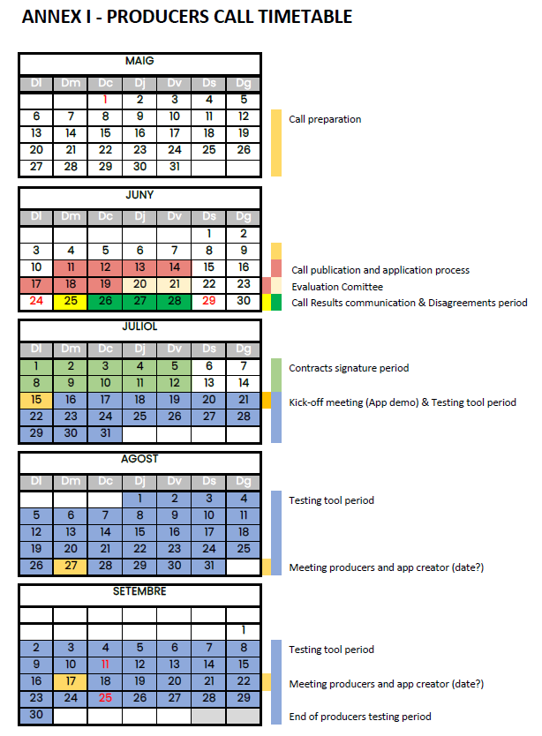

ANNEX II – APPLICATION FORM

SOULFOOD OPEN CALL FOR AGRIFOOD PRODUCERS

COMPANY DATA
Name and surname or company name
Identification number
Year of foundation
Fiscal address (street, postal code and town)

Country
CNAE code:
Number of employees:

NOTIFICATION DATA
Name and surname contact person
Company position
Telephone
Electronic Mail
Notifications will preferably be made by email.

ACTIVITY INFORMATION
Business name
Business adress
Number of different products grown
What products are they?
Number of hectares
Activity description
Why do you think it might be good for you to use the digital tool?

I PRESENT

That, with reference to the call relating to the bases that must govern the criteria for awarding the subsidy to agri-food producers, the company I represent meets all the requirements established in the bases.

I DECLARE, UNDER MY RESPONSIBILITY

- That I am aware that the provision of falsified or inaccurate data or documents may be grounds for canceling my/our request, notwithstanding that legal or appropriate actions may be taken.
- That I have not applied for any grant or aid for the same concept.
- That the population of the fiscal address is within the Republic of Lithuania
- That the company has less than 100 employees
- That the company's activity is within the CNAE codes mentioned in the application form
- That I am legally authorized to sign this statement on behalf of _______________ (Name of production company)
- That, (Name of the production company) _______________ has the appropriate legal capacity to participate in the call for proposals and especially to present all the required documentation
- That, (Company name) _______________ is not in bankruptcy, is not subject to insolvency or liquidation proceedings, its assets are not administered by a liquidator or by a court, is not in agreement with creditors, its commercial activities have not been suspended or are not in any similar situation resulting from a similar procedure provided for by national legislation or regulation
- That, (Name of production company) _______________ and any person legally authorized to represent it has not been involved in fraud, corruption, cooperation with a criminal organization, money laundering or other illegal activities
- That, (Name of the production company) _______________ has no obligation to reimburse state aid considered illegal or incompatible with the European market

I ACCEPT AND COMMIT
- The mere submission of the grant application implies knowledge and acceptance of the bases that regulate it.
- To provide the real data that are required for the granting of the subsidy and I declare under oath that the data provided are true.
- To notify AgriFood Lithuania DIH if any other subsidy or aid is received for the same concept in the future.
- That, if I am a beneficiary of the grant, I will submit to the verification and financial control actions carried out by AgriFood Lithuania DIH.
- That I will test the digital tool during the two test periods.
- That I will not directly or indirectly transfer or assign any part of the support to other purposes not included in the initial request.
- That I will follow the rules and requirements of the call and in accordance with the contract
- That I will designate a person who will direct the communication between the applicant and the SOULFOOD consortium throughout the duration of the project.
- That I will provide any information requested by the partners of the SOULFOOD consortium in order to ensure that these requirements are met with any request or written order received from the European Commission regarding the appropriate management of the test tool.
- That I will not have the right to require further support for the sole reason that I do not agree with the results of the support of the partners of the SOULFOOD consortium.
- I will fulfill all the conditions and burdens of the grant.

BANK DETAILS
Account number (The account holder must be the same interested person)

IBAN

I ASK
That the Subsidy of agrI-food producers be granted to me.
And, if granted, that the deposit be made to the bank account number of the owner or the company that has been indicated.

I AM ACCOMPANIING THE APPLICATION WITH THE FOLLOWING DOCUMENTATION:

- The present instance duly completed and signed
- DNI, NIE or NIF of the person signing the application
- NIF or CIF of the beneficiary of the grant
- FIC Declaration
- Proof of activity (CNAE)

Signature of the company's legal representative

Date:

(City, and date) __________________________________ 2024

In accordance with article 13 of Regulation (EU) 2016/679 of the European Parliament and of the Council, of April 27, 2016, relating to the protection of individuals with regard to the processing of personal data and the free circulation of this data and with article 11 of Organic Law 3/2018, of December 5, Protection of Personal Data and Guarantee of Digital Rights, we inform you that your data will be included in a data processing responsibility of the company AgriFood Lithuania DIH. The data will be used for the management of this request and the recipient of the information is the municipal company AgriFood Lithuania DIH, and will not be transferred to third parties, unless is necessary for the provision of the requested service in accordance with the legal and regulatory provisions applicable at any time or the unequivocal consent, as the case may be. Once the procedure has been handled, your data will be kept by legal obligation as part of the administrative procedure. For more information, consult our privacy policy.

Likewise, you can exercise your rights of access, rectification, cancellation, opposition, portability and limitation, by sending a letter to this effect, accompanied by a photocopy of your D.N.I. or equivalent supporting document, at the following address: AgriFood Lithuania DIH, Mokslininku str. 2, 08412 Vilnius, Lithuania, or sending it by email to edita@agrifood.lt.

ANNEX III – EVALUATION FORM

SOULFOOD OPEN CALL FOR AGRIFOOD PRODUCERS
Award Criterion  1 Score: | Product variety: how many different products the producer has? As more variety of products as better because there will be more testing results.
Award Criterion  2 Score: | FIC Declaration: The FIC (liet. ŪŪIK) is Lithuanian system to declare all the data of the agricultural holdings in a mandatory way by the producer. Does the agri-food producer have the FIC?
Award Criterion  3 Score: | Products without prior transformation. Companies with product/s that do not require prior transformation (so that they can be given to social entities directly). How many products has the company without prior transformation? As many products as better.
Award Criterion  4 Score: | Digital tool applicability. Explain how will the new digital app can help make use of the food surplus, what level of applicability it has in your company.

I declare that, to the best of my knowledge, I have no direct or indirect conflict of interest in the evaluation of this proposal.
The evaluator,
Name  Surname | –
Signature
Date

